Report Option B: Task 2

I create the declaration of a functions

Then check dataset is already have or not, if it not the dataset will download from yfinance and save to a file by using “ .to_csv() ”. If the dataset already have, it will read the data. A result dictionary is created and stored all the relevant data.

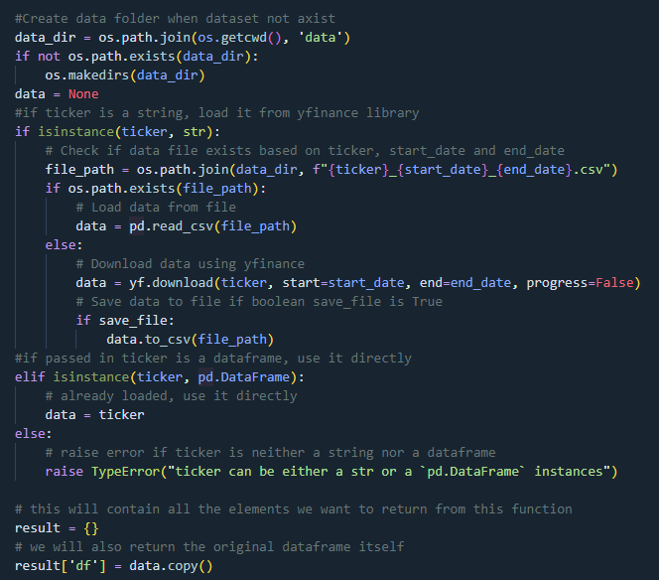

Next, Check the feature columns passed are in the data, then drop and fill the NaN base on the method passed as a parameter.

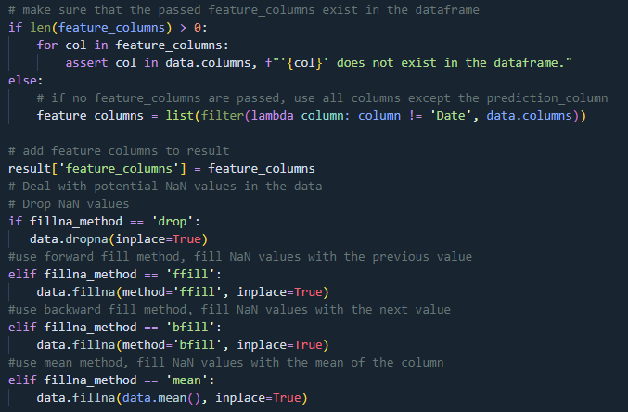

Then, the dataset will slip to train and test by date of the slip method is date or random with a radio. Using “.loc() method” to compare the value of ”date” columns and compare it with the passed split date. Then the dataset index is sorting.

Then, the data will be scaled using a Min-Max Scaler, with optional min and max scale parameters. For each feature column, a new scaler is initialized with the provided min and max values. The fit_transform method is applied to the training data, fitting the scaler and transforming the data simultaneously. For the test data, the transform method is used to scale the test data according to the scaler fitted on the training data. The data passed to the scaler is reshaped as necessary to ensure compatibility.

If required, the scalers are saved to a file using pickle. Finally, the scaled data is converted back into DataFrames and stored in a result dictionary.

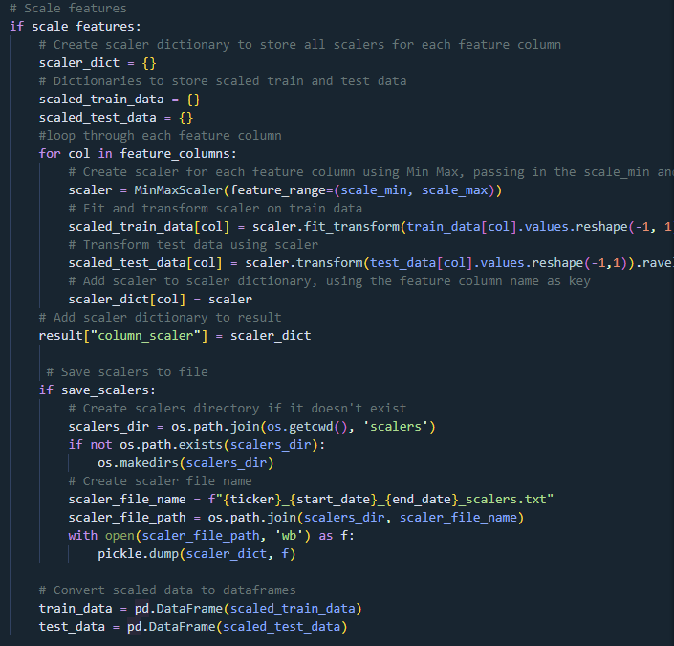

Finally, the scaled data is split into their respective X and y arrays, based on the same prediction days used in the original dataset. These arrays are then saved into the results dictionary before the final result is returned.

the main method, the parameters to be passed are defined and sent to the function. The results are saved into the data variable and then used to train the model and predict prices, similar to the original approach.



